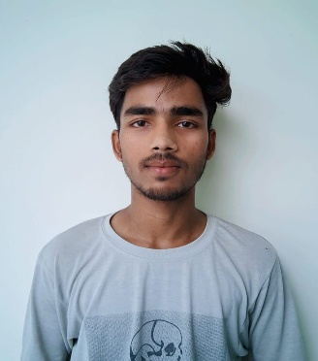**RESUME**

**PERSONAL DETAILS:.**

**Name**: Pritesh

**Date of Birth:** October 16,2004

**Address:**

**Phone Number:** 9667977535

**E-Mail:** ftd10622405@dseu.ac.in

**OBJECTIVE:**

To work as a intern in and IT firm

**EDUCATIONAL QUALIFICATIONS:**

**Course:** Diploma in Computer Engineering

**College:** DSEU Rajokari Campus

**Year:** 2022-Present

**Score:**

**CLASS XII**

**Board Name:.** Central Board of Secondary education (CBSE)

**Medium of teaching:** Hindi

**Year:** 2021-2022

**Score:** 77%

**CLASS X**

**Board Name:.** Central Board of Secondary education (CBSE)

**Medium of teaching:** Hindi

**Year:** 2019-2020

**Score:** 63%

**TECHNICAL SKILLS:**

Web Development, C, SQL, Python, PHP

**STRENGTHs:**

* Hardworking and sincere
* Fast Learning
* Team Work

**HOBBIES:**

Coding, listening music, cricket, book reading